12.1.9 Editors - Compositor Editor - Header - Add Menu - Converter
Detailed table of content 1
Add menu - Converter 4
Alpha Convert 4
Color Ramp 4
Combine HSVA 6
Combine RGBA 6
Combine YCbCrA 7
Combine YUVA 7
ID Mask 8
Math 9
RGB to BW 10
Separate HSVA 10
Separate RGBA 10
Separate YCbCrA 11
Separate YUVA 12
Set Alpha 12
View Switch 13

Detailed table of content
Detailed table of content
Detailed table of content 1
Add menu - Converter 4
Alpha Convert 4
Input 4
Image 4
Properties 4
Mapping Type 4
Output 4
Image 4
Color Ramp 4
Inputs 4
Factor 4
Properties 5
Color Ramp 5
Controls 5
+ 5
- 5
Tools menu 5
Flip Color Ramp 5
Distribute Stops from Left 5
Distribute Stops Evenly 5
Eyedropper (pipette icon) E 5
Reset Color Ramp 5
Color Mode 5
RGB 5
HSV/HSL 5
Interpolation 5
Ease 5
Cardinal 5
Linear 5
B-Spline 5
Constant 6
Color Ramp 6
Active Color Stop elements 6
Choose active color stop 6
Pos 6
Outputs 6
Image 6
Alpha 6
Combine HSVA 6
Input 6
H, S, V and A 6
Output 6
Color 6
Combine RGBA 6
Input 7
R, G, B and A 7
Output 7
Color 7
Combine YCbCrA 7
Input 7
Y, Cb, Cr and A 7
Properties 7
Modes 7
Output 7
Image 7
Combine YUVA 7
Input 7
Y, U, V and A 7
Output 8
Image 8
ID Mask 8
Inputs 8
ID value 8
Properties 8
Index 8
Anti-Aliased 8
Outputs 8
Alpha 8
Setup 8
Math 9
Inputs 9
Value 9
Value 9
Properties 9
Operation 9
Clamp 10
Outputs 10
Value 10
RGB to BW 10
Inputs 10
Image 10
Outputs 10
Value 10
Separate HSVA 10
Input 10
Color 10
Output 10
H , S, V and A 10
Separate RGBA 10
Input 11
Image 11
Output 11
R, G, Band A 11
Separate YCbCrA 11
Input 11
Y, Cb, Cr and A 11
Properties 11
Modes 11
Output 11
Image 11
Y 11
Cb 11
Cr 11
A 11
Separate YUVA 12
Input 12
Image 12
Output 12
Y 12
U 12
V 12
A 12
Set Alpha 12
Inputs 12
Image 12
Alpha 12
Outputs 12
Image 12
View Switch 13
Inputs 13
Left 13
Right 13
Outputs 13
Image 13

Add menu - Converter
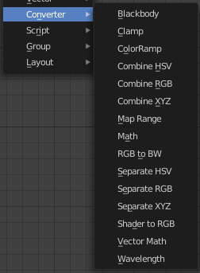
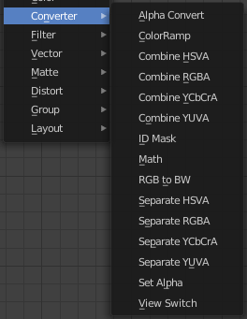
Here you find mainly nodes to convert data to another data.

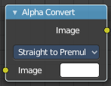
Alpha Convert
This node converts the alpha channel interpretation of an image from per-multiplied to straight or vice versa. With a straight alpha channel you might run into artifacts at the borders when the pixels in the semi transparent areas.

Input

Image
The input image.

Properties

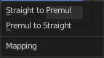
Mapping Type
Convert straight to premultiplied. Or convert premultiplied to straight.

Output

Image
The image output.

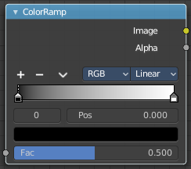
Color Ramp
The Color Ramp Node is used for mapping values to colors with the use of a gradient.

Inputs

Factor
The Factor input is used as an index for the color ramp.

Properties

Color Ramp
Color Ramps enables the user to specify a range of colors based on color stops. The color between the color stops gets interpolated.

Controls

+
Add a stop to your color ramp. The stop will be added after the selected one, in the middle to the next one.

-
Deletes the selected color stop from the list.


Tools menu

Flip Color Ramp
Flips the gradient, inverting the values of the color ramp.

Distribute Stops from Left
Rearrange the stops so that every step has the same space to the right.

Distribute Stops Evenly
Space between all neighboring stops becomes equal.

Eyedropper (pipette icon) E
An Eyedropper to sample a color or gradient from the interface to be used in the color ramp.

Reset Color Ramp

Resets the color ramp to its default state.

Color Mode

RGB
Blends color by mixing each color channel and combining.

HSV/HSL
Blends colors by first converting to HSV or HSL, mixing, then combining again. This has the advantage of maintaining saturation between different hues, where RGB would de-saturate, this allows for a richer gradient.


Interpolation

Ease
Uses an Ease Interpolation for the color stops.

Cardinal
Uses a Cardinal Interpolation for the color stops.

Linear
Uses a Linear Interpolation for the color stops.

B-Spline
Uses a B-Spline Interpolation for the color stops.

Constant
Uses a Constant Interpolation for the color stops.

Color Ramp
The color band. A click at one of the color stops makes it the active one. You can move the color stops by clicking at them and dragging them around.

Active Color Stop elements

Adjust the active color stop.

Choose active color stop
Choose the color stop by index.

Pos
The position of the active color stop. The range goes from 0.000 to 1.000

Outputs

Image
Image output.

Alpha
Alpha channel output.

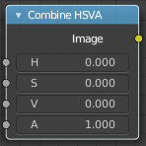
Combine HSVA
Combine the single HSV channels into a single image.

Input

H, S, V and A
The Hue, Saturation, Value and Alpha channels of an image.

Output

Color
Color output.

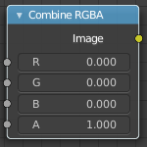
Combine RGBA
Combine the single RGB channels into a single image.

Input

R, G, B and A
The red, green, blue and alpha channels of an image.

Output

Color
Color output.

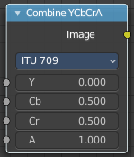
Combine YCbCrA
This node converts an YCbCrA image to RGBA color space and unions the channels.
Y: Luminance, 0=black, 1=white
Cb: Chrominance Blue, 0=Blue, 1=Yellow
Cr: Chrominance Red, 0=Red, 1=Yellow

Input

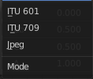
Y, Cb, Cr and A
Luminance, Chrominance Blue, Chrominance Red and Alpha input.

Properties

Modes
ITU 601, ITU 709, Jpeg. These are encoding standards for the YCbCrA color space.

Output

Image
Image output.

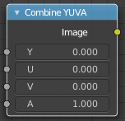
Combine YUVA
This node converts an YUVA image to RGBA color space. Note that U and V values range
from -0.5 to +0.5.

Input

Y, U, V and A
Luminance, Chrominance U, Chrominance V and Alpha channel.

Output

Image
Image output.

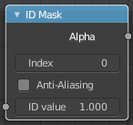
ID Mask
The ID Mask Node can be used to access an alpha mask per object or per material.

Inputs

ID value
Input for the Object Index or Material Index render pass. Which is an output of the Render Layers node or the Image node with a multi-layer format.

Properties

Index
Selection of the previously specified index.

Anti-Aliased
This post-process function refines the mask. See anti-aliasing.

Outputs

Alpha
The mask is white where the object is and black where it is not. If the object is transparent, the alpha mask represent that with gray values.

Setup
An index can be specify for any object or Cycles material in the scene. The Object Index can be set in the Relations panel in the Object tab in the Properties Editor. And for Cycles in the Settings Panel in the Material tab in the Properties editor. To be accessible after rendering, Object Index or Material Index render pass has to be enabled in the Passes panel in the View Layer properties tab in the Properties editor.
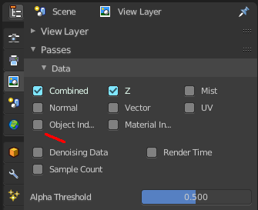
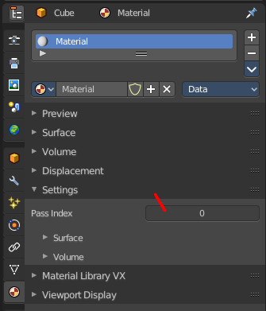
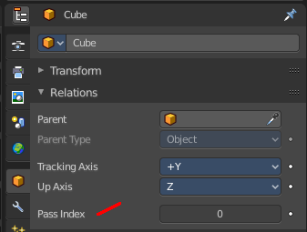

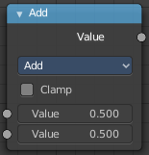
Math
The Math Node performs math operations.

Inputs

Value
First numerical value. The trigonometric functions accept values in radians.

Value
Second numerical value. This value is not used in functions that accept only one parameter like the trigonometric functions, Round and Absolute.

Properties

Operation
Here you can choose what mathematical operation to perform.
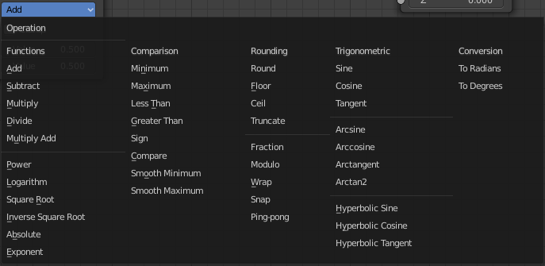

Clamp
Limits the output to the range (0 to 1). See clamp.

Outputs

Value
Numerical value output.

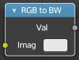
RGB to BW
The RGB to BW Node converts an RGB color image to a gray-scale image based at its luminance.

Inputs

Image
Color image input.

Outputs

Value
Gray-scale value output.

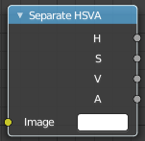
Separate HSVA
Combine the single RGB channels into a single image.

Input

Color
Color input.

Output

H , S, V and A
The Hue, Saturation, Value and Alpha channels of an image.

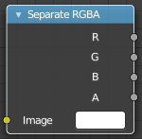
Separate RGBA
Combine the single RGBA channels into a single image.

Input

Image
The image input.

Output

R, G, Band A
The red, green, blue and alpha channels of an image.

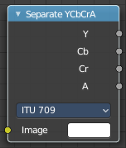
Separate YCbCrA
This node converts an RGBA image to YCbCrA color space, then splits each channel out to its own output so that they can be manipulated independently.

Input

Y, Cb, Cr and A
Luminance, Chrominance Blue, Chrominance Red and Alpha input.

Properties

Modes
ITU 601, ITU 709, Jpeg. These are encoding standards for the YCbCrA color space.

Output

Image

Y
Luminance output.

Cb
Chrominance Blue output.

Cr
Chrominance Red output.

A
Alpha channel output.

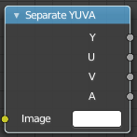
Separate YUVA
This node converts an RGBA image to YUVA color space. Note that U and V values range
from -0.5 to +0.5.

Input

Image
Image input.

Output

Y
Luminance output.

U
Chrominance U output.

V
Chrominance V.

A
Alpha channel.

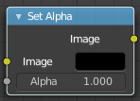
Set Alpha
The Set Alpha Node adds an alpha channel to an image.

Inputs

Image
Standard image input.

Alpha
The amount of Alpha can be set for the whole image by using the input field or per pixel by connecting to the socket.

Outputs

Image
The image output.

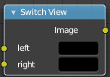
View Switch
The Switch View node combines the views (left and right) into a single Stereo 3D output. This can be useful if for example, you need to treat the view as separate images by combining each of the views.

Inputs

Left
Left-eye image input.

Right
Right-eye image input.

Outputs

Image
Stereo 3D image output.

